School of Computer Science and Engineering (SCOPE)

CSE2011-DATASTRUCTURES
LAB FAT

FALL 21-22

Name of the Student : Mayank Gupta
Register Number : 20BCE1538
Slot : L27+L28
Faculty Name : Dr.V.Vani

AIM Implementation of Stack Data Structure

CODE
#include<stdio.h>
#include<string.h>

char stack[200],top=-1;
void push(int n, int x) // push function is created
{

if(top>=n-1)
{
printf("\n\tSTACK is over flow");

}
else
{
top++;
stack[top]=x;
}
}
void pop() // pop function is created
{
if(top<=-1)
{
printf("\n\t Stack is under flow");
}
else
{
printf("\n\t The popped elements is %d",stack[top]);
top--;
}
}
void display() // display function is created
{
if(top>=0)
{
printf("\n The elements in STACK \n");
for(int i=top; i>=0; i--)
printf("\n%d",stack[i]);
printf("\n Press Next Choice");
}
else
{
printf("\n The STACK is empty");
}
}
void swap(char* x, char* y){ //swap function
char temp[20];
strcpy(temp,x); //string copy function is used
strcpy(x,y);
strcpy(y,temp);
}
int main()
{
char a[200][200];
int i,j,n;
printf("Enter no. of strings to be input = ");
scanf("%d",&n);
printf("Enter %d strings:\n",n);
for(i=0;i<n;i++){
scanf("%s",&a[i]);
push(n,a[i]);
}
for(i=0;i<n-1;i++) //sorting begins
{
for(j=0;j<n-i-1;j++)
{
if(strlen(a[j])>strlen(a[j+1])) // find the string having lowest no of character
{
swap(&a[j],&a[j+1]); // calling the swap function
}
}
}
printf("After Sorting :\n"); // printing starts
int x = strlen(a[0]);
int y ;
while ( y <=x-2 ) //string with lowest no. of char is printed
{
printf ( "%s\n",a[0] );
y++;
}

// printf("%s\n",a[0]);
for(i=0;i<n-x+1;i++){ //
printf("%s\n",a[i]);
}
printf("\nthe most repeated word in the output is :%s",a[0]);
// the string with lowest no. of char is placed at zero'th position(as it is sorted)

return 0;
}
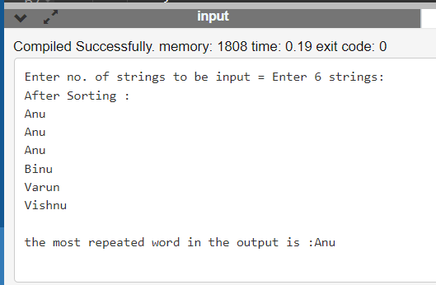

ALGORITHM
- Take “no. of string” as input(n)
- Take each string as input
- Then the strings are sorted as per the strlength
- Then the minimum string is replaced to it’s correct position using swap function
- Then using the display function the strings are printed as required

Push Operation
The process of putting a new data element onto stack is known as a Push Operation. Push operation involves a series of steps −

- Step 1 − Checks if the stack is full.

- Step 2 − If the stack is full, produces an error and exit.

- Step 3 − If the stack is not full, increments top to point next empty space.

- Step 4 − Adds data element to the stack location, where top is pointing.

- Step 5 − Returns success.

Stack Push Operation
If the linked list is used to implement the stack, then in step 3, we need to allocate space dynamically.

Algorithm for PUSH Operation
A simple algorithm for Push operation can be derived as follows −

begin procedure push: stack, data

if stack is full
return null
endif

top ← top + 1
stack[top] ← data

end procedure

Pop Operation
Accessing the content while removing it from the stack, is known as a Pop Operation. In an array implementation of pop() operation, the data element is not actually removed, instead top is decremented to a lower position in the stack to point to the next value. But in linked-list implementation, pop() actually removes data element and deallocates memory space.

A Pop operation may involve the following steps −

- Step 1 − Checks if the stack is empty.

- Step 2 − If the stack is empty, produces an error and exit.

- Step 3 − If the stack is not empty, accesses the data element at which top is pointing.

- Step 4 − Decreases the value of top by 1.

- Step 5 − Returns success.

Stack Pop Operation
Algorithm for Pop Operation
A simple algorithm for Pop operation can be derived as follows −

begin procedure pop: stack

if stack is empty
return null
endif

data ← stack[top]
top ← top - 1
return data

end procedure

